Caller HOWARD RICHMAN & PRINCESS CRUISES

Invite you, your family and friends

to sail and SQUARE DANCE with us on a

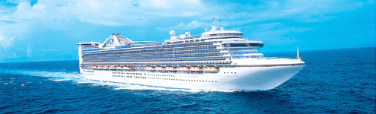

9-Day Cruise on the Caribbean Princess

Round-trip from NEW YORK - May 24 to June 02, 2009

Mainstream, Plus
and ABC dances for your non square dancing family & friends.

Ports of call: Grand Turk, San Juan, St. Thomas and Bermuda

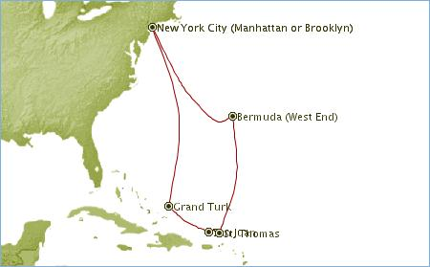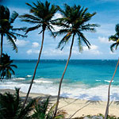

Howard Richman: http://www.cateringcowboy.com/Princess1.html

Caribbean Princess – Bermuda Registry

Reservation Form

Please indicate stateroom choice & number of guests.

*Prices per guest
Stateroom Category Double occupancy Single 3rd & 4th guest Deposit due by 11/20/2008
___ FF Ocean View/Obstructed $1,169 $1,753 $699 $ 284 Make check payable to
___ F Ocean View/Obstructed $1,149 $1,723 $699 $ 280 inTrend international travel
___J Inside $1,049 $1,573 $599 $ 260
___ KK Inside $1,049 $1,573 $599 $ 260

Deposit Amount $...........................

*Plus gov. fees, tax and fuel charges of $190.39 per guest.
All prices are per guest. In case of cancellation, deposit refundable less $50 cancellation fee per guest, prior to full payment. Final payment due by March 02, 2009.

PLEASE PRINT

Name: First guest__________________________________Second guest____________________________________

Third guest_________________________________ Fourth guest____________________________________

Address:_________________________________________________________________________________________

City:__________________________________________________State:________________ Zip:__________________

Telephone:_________________________ Email:______________________________________________________

US Citizen Y / N If no, from what country?__________________________________________________________

Dining: Early / Late Group Travel Insurance by Travel Guard: Y / N
Travel insurance is strongly recommended!
$ 89 per person for trip cost up to $1500
$110 per person for trip cost up to $2000

Signature________________________________________________________________________________________

Excursions: Are you interested in shore excursions? Y / N Do you want to share a room? Y / N

Comments: _________________________________________________________________________________________________

_________________________________________________________________________________________________

Mail your reservation and check to:

4 Ravenswood Court, West Nyack, NY 10994
Tel: 845-510-9630 Fax: 845-510-9633 Email: greta@intrend.com - www.intrend.com
Please email or call Greta with any questions.

